

Relationships Education, Relationships Sex Education (RSE)
and Health Education Policy (for teaching until 31 August 2026) - Primary

Reviewed on |  | 2025/26, Term 1 |  | Review frequency |  | Annual
Next review due |  | 2026/27, Term 1 |  | Template Yes / No |  | Yes
Owner |  | Dir of Ed, Primary |  | Approved by |  | Board of Trustees

History of Policy Changes

Date | Page | Change | Origin of Change
Sep 25 | All | References to Governing Body changed to Local Governing Committee | Annual Review
Sep 25 | All | References to Headteacher changed to School Leader | Annual Review
Sep 25 |  | This policy has been redrafted in line with DfE Guidance and should be reviewed in its entirety, before approval. | Annual Review

1. Introduction 3
2. Scope 3
3. Definitions 4
4. Introduction and Statutory Guidance 4
5. Equality 4
6. Pupils with Special Educational Needs and Disabilities 5
7. Lesbian, Gay, Bisexual and transgender (LGBT) 5
8. Use of Materials 6
9. Governors 6
10. Working with Parents/Carers and the Wider Community 6
11. Right to be Excused from Sex Education (Commonly Referred to as the Right to Withdraw) 6
12. Working with External Agencies 7
13. Flexibility 7
14. Safeguarding, Reports of Abuse and Confidentiality 7
15. Delivering the Relationship and Health Education Curriculum at [insert school name] 8
16. Ensuring the Church Values are Reflected 9
17. Assessment 10
18. Monitoring of RHE 10
19. Appendix 1 - Statutory Primary RSE Content September 2025 – August 2026 11
20. Appendix 2 – RHE Curriculum Overview 18
21. Review 18

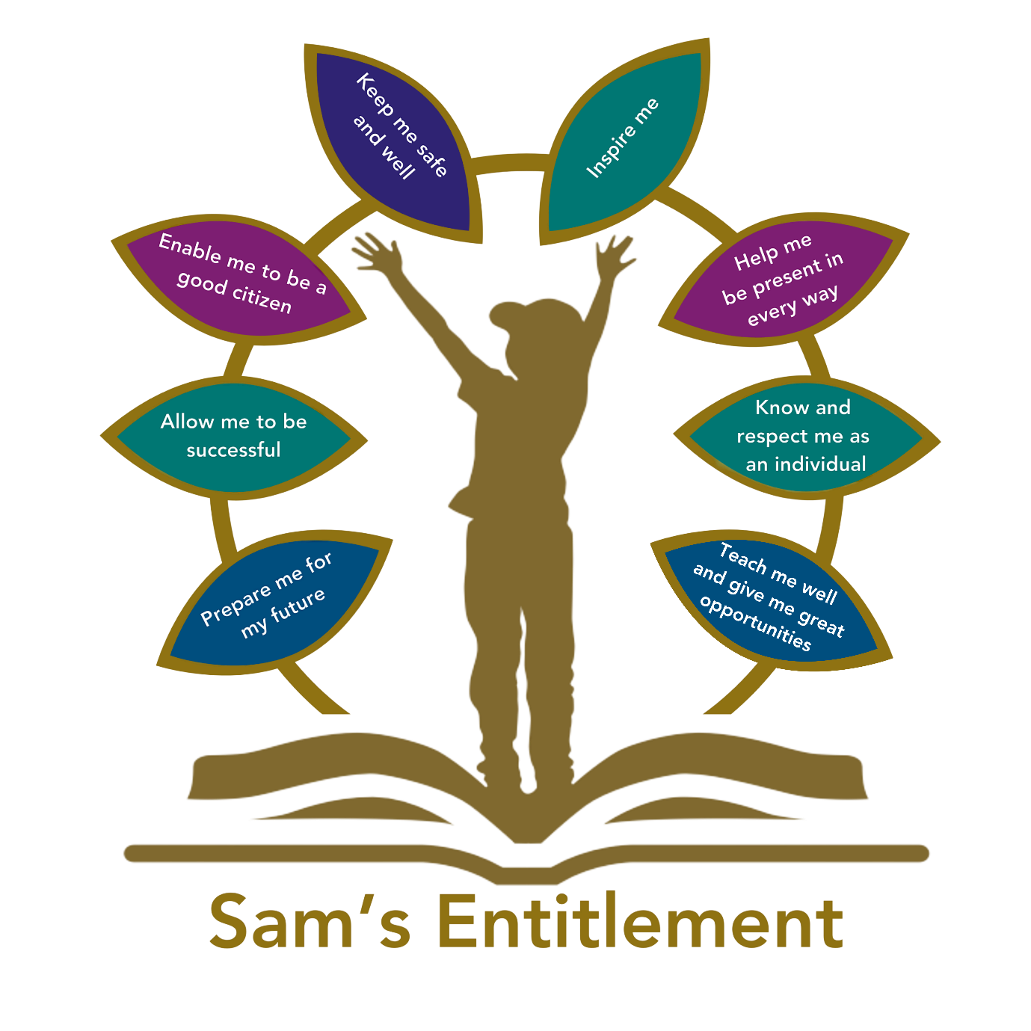

Introduction

Hamwic Education Trust (HET) believe that all pupils should receive a high quality, enriching, learning experience in a safe and inclusive environment, which promotes excellence through a broad curriculum that prepares them for their future and opens doors to a diverse array of opportunities as well as that all pupils and adults within HET flourish as individuals and together.

Scope

This policy is for all employees working within a HET school or establishment (which for ease of reference are referred to throughout this document as ‘schools’) or the HET Managed Service (MS) Team.

It does not apply to agency workers, consultants, self-employed contractors, volunteers or work experience students.

Definitions

- HR’ in this policy, means Hamwic Education Trust HR.
- ‘Local Governing Committee’ in this policy, where reference is made to the Governing Committee, this means the Local Governing Committee of the school, or the Trust in the case of a school where no Local Governing Committee is present. Where a Governing Committee is not present in a school, or numbers are low, Governors from other schools/partnerships may be used.
- ‘Manager’ in this policy, is anyone as identified in the staffing structure with line management responsibilities.

Introduction and Statutory Guidance

This Policy is written in line with the Relationships Education, Relationships and Sex Education (RSE) and Health Education Statutory Guidance July 2025.
https://assets.publishing.service.gov.uk/media/62cea352e90e071e789ea9bf/Relationships_Education_RSE_and_Health_Education.pdf

In addition to the Statutory Guidance

- As a primary school we must provide relationships education to all pupils as per section 34 of the Children and Social work act 2017.
- HET chooses to follow the National Curriculum. This includes the requirement to teach the elements of sex education contained in the science curriculum. At Livingstone Road Primary Federation we follow the national curriculum for science.
- In teaching Relationships and Health Education, we are required by our funding agreements to have regard to guidance issued by the secretary of state as outlined in section 403 of the Education Act 1996.

Learning will be planned to meet the objectives set out in the Relationships Education, Sex Education (RSE) and Health Education Statutory Guidance 2025 (see appendix 1), under the broad headings of

- Relationships
- Health and Wellbeing
- Living in Wider World
- Safety
Teachers will also take all opportunities to discuss positive emotional and mental well-being with children. The characteristics that will be taught are also reflected in the school values at Livingstone Road Primary Federation:

- The whole child
- Unity
- Learning
- Inspiration

Equality

Livingstone Road Primary Federation is required to comply with relevant requirements of the Equality Act 2010.

Under the provisions of the Equality Act, schools must not unlawfully discriminate against pupils because of their age, sex, race, disability, religion or belief, gender reassignment, pregnancy or maternity, marriage or civil partnership11, or sexual orientation (collectively known as the protected characteristics). Schools must also make reasonable adjustments to alleviate disadvantage and be mindful of the SEND Code of Practice when planning for these subjects

Schools should consider the makeup of their own student body, including the gender and age range of their pupils, and consider whether it is appropriate or necessary to put in place additional support for pupils with particular protected characteristics (which mean that they are potentially at greater risk). Schools should consider what they can do to foster healthy and respectful peer-to-peer communication and behaviour between boys and girls, and provide an environment, which challenges perceived limits on pupils based on their gender or any other characteristic, including through these subjects and as part
of a whole-school approach.

Schools should be alive to issues such as everyday sexism, misogyny, homophobia and gender stereotypes and take positive action to build a culture where these are not tolerated, and any occurrences are identified and tackled. Staff have an important role to play in modelling positive behaviours. School pastoral and behaviour policies should support all pupils.

Pupils with Special Educational Needs and Disabilities

Livingstone Road Primary Federation must ensure that Relationships Education, RSE and Health Education is accessible for all pupils. This is particularly important when planning teaching for pupils with special educational needs and disabilities who represent a large minority of pupils. High quality teaching that is differentiated and personalised will be the starting point to ensure accessibility. Livingstone Road Primary Federation will be mindful of the preparing for adulthood outcomes, as set out in the SEND code of practice, when teaching these subjects to those with SEND.

Livingstone Road Primary Federation will be aware that some pupils are more vulnerable to exploitation, bullying and other issues due to the nature of their SEND. Relationships Education and RSE can also be particularly important subjects for some pupils; for example, those with Social, Emotional and Mental Health needs or learning disabilities. Such factors will be taken into consideration in designing and teaching these subjects.

Lesbian, Gay, Bisexual and transgender (LGBT)

In teaching Relationships Education and RSE, Livingstone Road Primary Federation should ensure that the needs of all pupils are appropriately met and that all pupils understand the importance of equality and respect. Livingstone Road Primary Federation must ensure that it complies with the relevant provisions of the Equality Act 2010, (please see The Equality Act 2010 and schools: Departmental advice), under which sexual orientation and gender reassignment are amongst the protected characteristics.

Livingstone Road Primary Federation will ensure that all their teaching is sensitive and age appropriate in approach and content. At the point at which schools consider it appropriate to teach their pupils about LGBT, they should ensure that this content is fully integrated into their programmes of study for this area of the curriculum rather than delivered as a stand-alone unit or lesson. Statutory guidance says that schools are free to determine how they do this, and it is expected all pupils will have been taught LGBT content at a timely point as part of this area of the curriculum.

Use of Materials

There are a lot of excellent resources available, free-of-charge, which schools can draw on when delivering these subjects. Livingstone Road Primary Federation will assess each resource that we propose to use to ensure that it is appropriate for the age and maturity of pupils, and sensitive to their needs.

When consulting with parents, the school will provide examples of the resources it plans to use as this can be reassuring for parents and enables them to continue the conversations started in class at home.

Parents may like to see the suggested resource list, found in Annex B of the 2025 statutory guidance document.

Relationships Education, Relationships and Sex Education and Health Education guidance

Governors

As well as fulfilling their legal obligations, Livingstone Road Primary Federation’s Local Governing Committee (LGC) will also make sure that:

- all pupils make progress in achieving the expected educational outcomes;
- the subjects are well led, effectively managed and well planned;
- the quality of provision is subject to regular and effective self-evaluation;
teaching is delivered in ways that are accessible to all pupils with SEND;
- clear information is provided for parents on the subject content and the right to request that their child is withdrawn; and,
- the subjects are resourced, staffed and timetabled in a way that ensures that
- the school can fulfil its legal obligations.

Foundation Governors and Foundation Trustees will also have wider responsibilities in relation to maintaining and developing the religious ethos of their schools.

Working with Parents/Carers and the Wider Community

Livingstone Road Primary Federation will work closely with parents when planning and delivering these subjects. We will ensure that parents know what will be taught and when, and clearly communicate the fact that parents have the right to request that their child be withdrawn from some or all of sex education delivered as part of statutory RSE.

Parents should be given every opportunity to understand the purpose and content of Relationships Education and RSE. We will ensure that there is good communication and opportunities for parents to understand and ask questions about the school’s approach help secure their confidence in the curriculum.

Right to be Excused from Sex Education (Commonly Referred to as the Right to Withdraw)

Parents have the right to request that their child be withdrawn from some or all of sex education delivered as part of statutory RSE. Before granting any such request the School Leader will discuss the request with parents and as appropriate, with the child to ensure that their wishes are understood and to clarify the nature and purpose of the curriculum. School Leaders will document this process to ensure a record is kept.

This process is the same for pupils with SEND. However, there may be exceptional circumstances where the School Leader may want to take a pupil’s specific needs arising from their SEND into account when making this decision.

School Leaders will automatically grant a request to withdraw a pupil from any sex education delivered in primary schools, other than as part of the science curriculum.

If a pupil is excused from sex education, it is the school’s responsibility to ensure that the pupil receives appropriate, purposeful education during the period of withdrawal. There is no right to withdraw from Relationships Education or Health Education.

Working with External Agencies

Working with external organisations can enhance delivery of these subjects, bringing in specialist knowledge and different ways of engaging with young people.

As with any visitor, schools are responsible for ensuring that they check the visitor or visiting organisation’s credentials. Livingstone Road Primary Federation will ensure that the teaching delivered by the visitor fits with their planned programme and their published policy. The school will ask to see the materials visitors will use as well as a lesson plan in advance to ensure it meets the full range of pupils’ needs (e.g. special educational needs). School will agree how confidentiality will work in any lesson and that the visitor understands how safeguarding reports should be dealt with in line with school policy.

Use of visitors should be to enhance teaching by an appropriate member of the teaching staff, rather than as a replacement for teaching by those staff.

Flexibility

Livingstone Road Primary Federation will retain freedom to determine an age-appropriate, developmental curriculum which meets the needs of young people, is developed in consultation with parents and the local community. Schools must also comply with the relevant provisions of the Equality Act as noted earlier. Where appropriate this may also require a differentiated curriculum. Schools have specific duties to increase the extent to which disabled pupils can participate in the curriculum.

Flexibility is important as it allows schools to respond to local public health and community issues, meet the needs of their community and adapt materials and programmes to meet the needs of pupils (for example in teaching about gangs or high local prevalence of specific sexually transmitted infections).

Safeguarding, Reports of Abuse and Confidentiality

Livingstone Road Primary Federation will ensure the focus remains on keeping children safe, and play discharge our role in preventative education. Keeping Children Safe in Education (KCSIE) sets out that all schools and colleges should ensure children are taught about safeguarding, including how to stay safe online, as part of providing a broad and balanced curriculum.

Children will be made aware of how to raise their concerns or make a report and how any report will be handled. This should include processes when they have a concern about a friend or peer.

KCSIE is clear that all staff should know what to do if a pupil tells them that they are being abused or neglected or are witnessing abuse. Staff should know how to manage the requirement to maintain an appropriate level of confidentiality. This means only involving those who need to be involved, such as the Designated Safeguarding Lead (or deputy) and children’s social care. Staff should never promise a child that they will not tell anyone about a report of abuse, as this may ultimately not be in the best interests of
the child.

Livingstone Road Primary Federation will involve the Designated Safeguarding Lead (or a deputy) in anything that is safeguarding-related in the context of these subjects. They will potentially have knowledge of trusted, high quality local resources that could be engaged, links to the police and other agencies and the knowledge of any local issues which it may be appropriate to address in lessons.

When external agencies are invited in to support delivery of these subjects, there will be agreement in advance of the session how a safeguarding report should be dealt with by the external visitor. We believe important that children understand how confidentiality will be handled in a lesson and what might happen if they choose to make a report.

If teachers have concerns about a specific pupil in relation to self-harm or suicidal ideation or attempts, they must follow safeguarding procedures.

Delivering the Relationship and Health Education Curriculum at Livingstone Road Primary Federation

Relationships and Health Education (RHE) is taught through weekly lessons linked to the PSHE association programme and links with the whole school assembly programme. An overview of the broad topics covered, and the linked Relationship and Health objectives can be found in Appendix 2.

Biological aspects of sex education are taught within the science curriculum in line with the age expectations set out in the National curriculum.

The areas of learning are taught within the context of family life taking care to ensure that there is no stigmatisation of children based on their home circumstances (families can include single parent families, LGBT parents, families headed by grandparents, adoptive parents, foster parents/carers amongst other structures) along with reflecting sensitively that some children may have a different structure of support around them (for example: looked after children or young carers).
We are mindful that some children with SEND may need additional support to understand the themes and learning within the relationships and health education curriculum. Teachers will draw on their knowledge of the child to ensure learning is adapted appropriately.
We will keep abreast of local contextual issues and support these through our curriculum where possible.

Pupils will be given the opportunity to explore their own attitudes, values and beliefs and to develop an individual moral code that will guide their actions, as is their human right. Our focus is on building healthy attitudes and positive relationships in an environment where difference is celebrated, and everyone is included and valued for who they are.

Assessment

Livingstone Road Primary Federation will have the same high expectations of the quality of pupils’ work in these subjects as for other curriculum areas. A strong curriculum will build on the knowledge pupils have previously acquired, including in other subjects, with regular feedback provided on pupil progress.

Lessons should be planned to ensure that pupils of differing abilities, including the most able, are suitably challenged. Teaching should be assessed and assessments used to identify where pupils need extra support, adaptation or intervention.

Monitoring of RHE

The delivery of RHE is monitored by Senior Leaders to ensure provision can be further strengthened. The RHE leader carries out monitoring through:

- Planning scrutiny
- Lesson observation
- Analysis of pupils’ work and discussions with pupils
- Monitoring of SEN plans and IEPs where appropriate
- Sampling of pupils’ end of year reports

Appendix 1 - Statutory Primary RSE Content September 2025 – August 2026

https://assets.publishing.service.gov.uk/media/62cea352e90e071e789ea9bf/Relationships_Education_RSE_and_Health_Education.pdf

Relationships Education (Primary)

The focus in primary school should be on teaching the fundamental building blocks and characteristics of positive relationships, with particular reference to friendships, family relationships, and relationships with other children and with adults.

This starts with pupils being taught about what a relationship is, what friendship is, what family means and who the people are who can support them. From the beginning of primary school, building on early education, pupils should be taught how to take turns, how to treat each other with kindness, consideration and respect, the importance of honesty and truthfulness, permission seeking and giving, and the concept of personal privacy. Establishing personal space and boundaries, showing respect and understanding the differences between appropriate and inappropriate or unsafe physical, and other, contact – these are the forerunners of teaching about consent, which takes place at secondary.

Respect for others should be taught in an age-appropriate way, in terms of understanding one’s own and others’ boundaries in play, in negotiations about space, toys, books, resources and so on.

From the beginning, teachers should talk explicitly about the features of healthy friendships, family relationships and other relationships which young children are likely to encounter. Drawing attention to these in a range of contexts should enable pupils to form a strong early understanding of the features of relationships that are likely to lead to happiness and security. This will also help them to recognise any less positive relationships when they encounter them.

The principles of positive relationships also apply online especially as, by the end of primary school, many children will already be using the internet. When teaching relationships content, teachers should address online safety and appropriate behaviour in a way that is relevant to pupils’ lives. Teachers should include content on how information and data is shared and used in all contexts, including online; for example, sharing pictures, understanding that many websites are businesses and how sites may use information provided by users in ways they might not expect.

Teaching about families requires sensitive and well-judged teaching based on knowledge of pupils and their circumstances. Families of many forms provide a nurturing environment for children. (Families can include for example, single parent families, LGBT parents, families headed by grandparents, adoptive parents, foster parents/carers amongst other structures.) Care needs to be taken to ensure that there is no stigmatisation of children based on their home circumstances and needs, to reflect sensitively that some children may have a different structure of support around them, e.g. looked after children or young carers.

A growing ability to form strong and positive relationships with others depends on the deliberate cultivation of character traits and positive personal attributes, (sometimes referred to as ‘virtues’) in the individual. In a school wide context which encourages the development and practice of resilience and other attributes, this includes character traits such as helping pupils to believe they can achieve, persevere with tasks, work towards long-term rewards and continue despite setbacks. Alongside understanding the importance of self-respect and self-worth, pupils should develop personal attributes including honesty, integrity, courage, humility, kindness, generosity, trustworthiness and a sense of justice. This can be achieved in a variety of ways including by providing planned opportunities for young people to undertake social action, active citizenship and voluntary service to others locally or more widely.

Relationships Education also creates an opportunity to enable pupils to be taught about positive emotional and mental wellbeing, including how friendships can support mental wellbeing.

Through Relationships Education (and RSE), schools should teach pupils the knowledge they need to recognise and to report abuse, including emotional, physical and sexual abuse. In primary schools, this can be delivered by focusing on boundaries and privacy, ensuring young people understand that they have rights over their own bodies. This should also include understanding boundaries in friendships with peers and also in families and with others, in all contexts, including online.

Pupils should know how to report concerns and seek advice when they suspect or know that something is wrong. At all stages it will be important to balance teaching children about making sensible decisions to stay safe (including online) whilst being clear it is never the fault of a child who is abused and why victim blaming is always wrong. These subjects complement Health Education and as part of a comprehensive programme and whole school approach, this knowledge can support safeguarding of children.

By the end of primary school:

Families and people who care for me | Pupils should know  - that families are important for children growing up because they can give love, security and stability.  - the characteristics of healthy family life, commitment to each other, including in times of difficulty, protection and care for children and other family members, the importance of spending time together and sharing each other’s lives.  - that others’ families, either in school or in the wider world, sometimes look different from their family, but that they should respect those differences and know that other children’s families are also characterised by love and care.  - that stable, caring relationships, which may be of different types, are at the heart of happy families, and are important for children’s security as they grow up.  - that marriage represents a formal and legally recognised commitment of two people to each other which is intended to be lifelong.  - how to recognise if family relationships are making them feel unhappy or unsafe, and how to seek help or advice from others if needed.
Caring friendships | Pupils should know  - how important friendships are in making us feel happy and secure, and how people choose and make friends.  - the characteristics of friendships, including mutual respect, truthfulness, trustworthiness, loyalty, kindness, generosity, trust, sharing interests and experiences and support with problems and difficulties.  - that healthy friendships are positive and welcoming towards others, and do not make others feel lonely or excluded.  - that most friendships have ups and downs, and that these can often be worked through so that the friendship is repaired or even strengthened, and that resorting to violence is never right.  - how to recognise who to trust and who not to trust, how to judge when a friendship is making them feel unhappy or uncomfortable, managing conflict, how to manage these situations and how to seek help or advice from others, if needed.
Respectful relationships | Pupils should know  - the importance of respecting others, even when they are very different from them (for example, physically, in character, personality or backgrounds), or make different choices or have different preferences or beliefs.  - practical steps they can take in a range of different contexts to improve or support respectful relationships.  - the conventions of courtesy and manners.  - the importance of self-respect and how this links to their own happiness.  - that in school and in wider society they can expect to be treated with respect by others, and that in turn they should show due respect to others, including those in positions of authority.  - about different types of bullying (including cyberbullying), the impact of bullying, responsibilities of bystanders (primarily reporting bullying to an adult) and how to get help.  - what a stereotype is, and how stereotypes can be unfair, negative or destructive.  - the importance of permission-seeking and giving in relationships with friends, peers and adults.
Online relationships | Pupils should know  - that people sometimes behave differently online, including by pretending to be someone they are not.  - that the same principles apply to online relationships as to face-toface relationships, including the importance of respect for others online including when we are anonymous.  - the rules and principles for keeping safe online, how to recognise risks, harmful content and contact, and how to report them.  - how to critically consider their online friendships and sources of information including awareness of the risks associated with people they have never met.  - how information and data is shared and used online.
Being safe | Pupils should know  - what sorts of boundaries are appropriate in friendships with peers and others (including in a digital context).  - about the concept of privacy and the implications of it for both children and adults; including that it is not always right to keep secrets if they relate to being safe.  - that each person’s body belongs to them, and the differences between appropriate and inappropriate or unsafe physical, and other, contact.  - how to respond safely and appropriately to adults they may encounter (in all contexts, including online) whom they do not know.  - how to recognise and report feelings of being unsafe or feeling bad about any adult.  - how to ask for advice or help for themselves or others, and to keep trying until they are heard.  - how to report concerns or abuse, and the vocabulary and confidence needed to do so.  - where to get advice e.g. family, school and/or other sources.

The Science Curriculum - body changes and life cycles

Sex Education beyond the requirements of the science national curriculum is not compulsory in primary schools; however, we recognise the importance of preparing children well for secondary school. At Livingstone Road Primary Federation children will be taught about puberty as set out in the expectations of the science National Curriculum.

In line with year group expectations, children will learn about external body parts, changes in the human body from birth to old age, and reproduction in some plants and animals. As part of the life cycle objectives, Year 6 pupils (or year 5 pupils if you keep this in line with the NC y5 objective) will be taught the science of how a baby is conceived and born. In our school, we only teach the body changes and life cycles required by the science national curriculum. Therefore, parents do not have the right to withdraw children from these scientific lessons. (Parents will have the opportunity to discuss and view the content of the Year 5/6 curriculum before it is taught.)

We recognise that during such lessons, children may have questions as a result of their learning. We are mindful that unanswered questions often lead to misconceptions and will aim to avoid this where possible.

When questions arise, they will be dealt with as follows.

- Questions directly linked with the science taught will be answered factually for the class of individual. Children will be given the opportunity to write anonymous questions submitted via a question box
- Questions of a personal nature directly linked to the teaching may need to be dealt with by talking directly to the child with an additional adult also present. If deemed necessary, teachers will inform parents of the questions asked. Wherever possible, and to maintain some anonymity, questions will be answered in front of all pupils via a mechanism such as a question box.
- Where a question relates to sex education beyond the scientific teaching, children will be advised to ask their parents or carers.

Physical Health and Mental wellbeing

https://www.gov.uk/government/publications/relationships-education-relationships-and-sex-education-rse-and-health-education/physical-health-and-mental-wellbeing-primary-and-secondary

By the end of primary school:

Mental wellbeing | Pupils should know:  - that mental wellbeing is a normal part of daily life, in the same way as physical health  - that there is a normal range of emotions (e.g. happiness, sadness, anger, fear, surprise, nervousness) and scale of emotions that all humans experience in relation to different experiences and situations  - how to recognise and talk about their emotions, including having a varied vocabulary of words to use when talking about their own and others’ feelings  - how to judge whether what they are feeling and how they are behaving is appropriate and proportionate  - the benefits of physical exercise, time outdoors, community participation, voluntary and service-based activity on mental wellbeing and happiness  - simple self-care techniques, including the importance of rest, time spent with friends and family and the benefits of hobbies and interests  - isolation and loneliness can affect children and that it is very important for children to discuss their feelings with an adult and seek support  - that bullying (including cyberbullying) has a negative and often lasting impact on mental wellbeing  - where and how to seek support (including recognising the triggers for seeking support), including whom in school they should speak to if they are worried about their own or someone else’s mental wellbeing or ability to control their emotions (including issues arising online)  - it is common for people to experience mental ill health. For many people who do, the problems can be resolved if the right support is made available, especially if accessed early enough
Internet safety and harms | - Pupils should know:  - that for most people the internet is an integral part of life and has many benefits  - about the benefits of rationing time spent online, the risks of excessive time spent on electronic devices and the impact of positive and negative content online on their own and others’ mental and physical wellbeing  - how to consider the effect of their online actions on others and know how to recognise and display respectful behaviour online and the importance of keeping personal information private  - why social media, some computer games and online gaming, for example, are age restricted  - that the internet can also be a negative place where online abuse, trolling, bullying and harassment can take place, which can have a negative impact on mental health  - how to be a discerning consumer of information online including understanding that information, including that from search engines, is ranked, selected and targeted  - where and how to report concerns and get support with issues online
Physical health and fitness | Pupils should know:  - the characteristics and mental and physical benefits of an active lifestyle  - the importance of building regular exercise into daily and weekly routines and how to achieve this; for example walking or cycling to school, a daily active mile or other forms of regular, vigorous exercise  - the risks associated with an inactive lifestyle (including obesity)  - how and when to seek support including which adults to speak to in school if they are worried about their health
Healthy eating | Pupils should know:  - what constitutes a healthy diet (including understanding calories and other nutritional content)  - the principles of planning and preparing a range of healthy meals  - the characteristics of a poor diet and risks associated with unhealthy eating (including, for example, obesity and tooth decay) and other behaviours (e.g. the impact of alcohol on diet or health)
Drugs, alcohol and tobacco | Pupils should know:  - the facts about legal and illegal harmful substances and associated risks, including smoking, alcohol use and drug-taking
Health and prevention | Pupils should know:  - how to recognise early signs of physical illness, such as weight loss, or unexplained changes to the body  - about safe and unsafe exposure to the sun, and how to reduce the risk of sun damage, including skin cancer  - the importance of sufficient good quality sleep for good health and that a lack of sleep can affect weight, mood and ability to learn  - about dental health and the benefits of good oral hygiene and dental flossing, including regular check-ups at the dentist  - about personal hygiene and germs including bacteria, viruses, how they are spread and treated, and the importance of handwashing  - the facts and science relating to allergies, immunisation and vaccination
Basic first aid | Pupils should know:  - how to make a clear and efficient call to emergency services if necessary  - concepts of basic first-aid, for example dealing with common injuries, including head injuries
Changing adolescent body | Pupils should know:  - key facts about puberty and the changing adolescent body, particularly from age 9 through to age 11, including physical and emotional changes  - about menstrual wellbeing including the key facts about the menstrual cycle

The policy should be read in conjunction with:

• Keeping Children Safe in Education (statutory guidance)
https://www.gov.uk/government/publications/keeping-children-safe-in-education--2
• Respectful School Communities: Self Review and Signposting Tool (a tool to support a whole school approach that promotes respect and discipline) http://educateagainsthate.com/download/36/
• Behaviour and Discipline in Schools (advice for schools, including advice for appropriate behaviour between pupils) https://www.gov.uk/government/publications/behaviour-and-discipline-in-schools
• Equality Act 2010 and schools https://www.gov.uk/government/publications/equality-act-2010-advice-for-schools
• SEND code of practice: 0 to 25 years (statutory guidance) https://www.gov.uk/government/publications/send-code-of-practice-0-to-25
• Alternative Provision (statutory guidance) https://www.gov.uk/government/publications/alternative-provision
• Mental Health and Behaviour in Schools (advice for schools) https://www.gov.uk/government/publications/mental-health-and-behaviour-in-schools--2
• Preventing and Tackling Bullying (advice for schools, including advice on cyberbullying) https://www.gov.uk/government/publications/preventing-and-tackling-bullying
• Sexual violence and sexual harassment between children in schools (advice for schools) https://www.gov.uk/government/publications/sexual-violence-and-sexual-harassment-between-children-in-schools-and-colleges
• The Equality and Human Rights Commission Advice and Guidance (provides advice on avoiding discrimination in a variety of educational contexts) https://www.equalityhumanrights.com/en/advice-and-guidance/
• Promoting Fundamental British Values as part of SMSC in schools (guidance for maintained schools on promoting basic important British values as part of pupils’ spiritual, moral, social and cultural (SMSC)
https://www.gov.uk/government/uploads/system/uploads/attachment_data/file/380595/SMSC_Guidance_Maintained_Schools.pdf
• National Citizen Service guidance for schools https://www.gov.uk/government/publications/national-citizen-service-guidance-for-schools-and-colleges

Appendix 2 – RHE Curriculum Overview

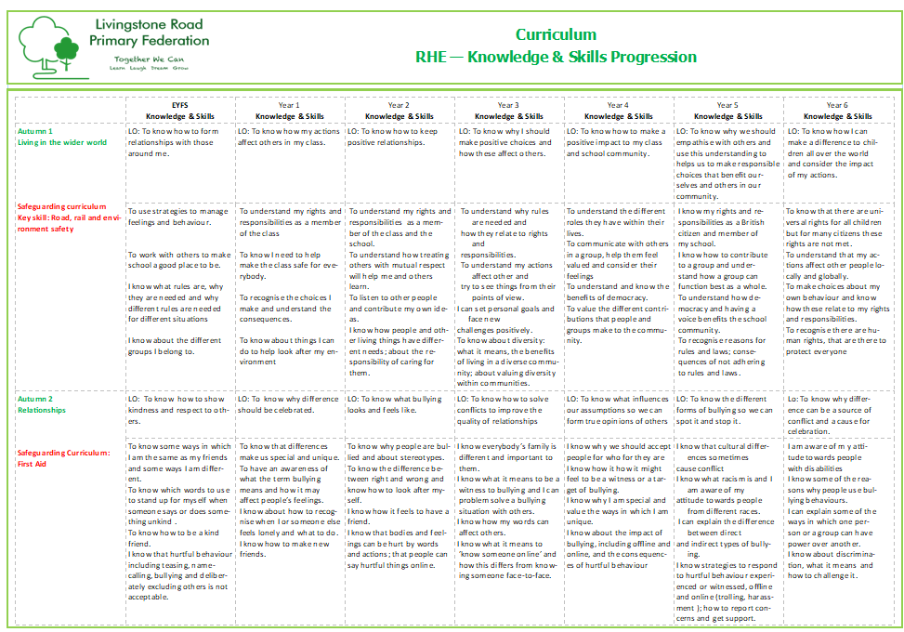

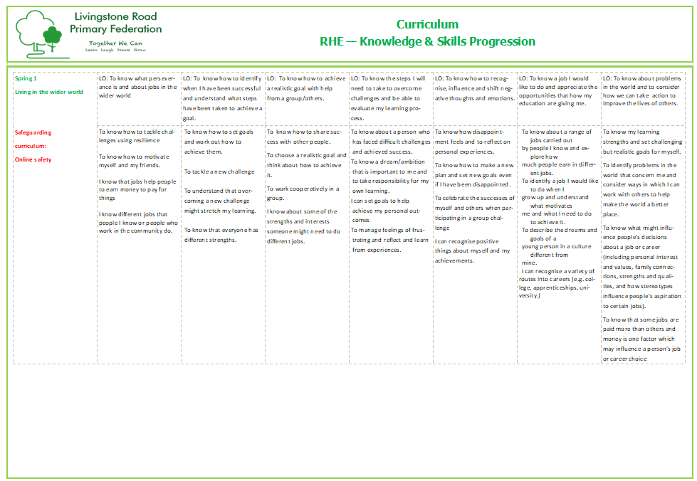

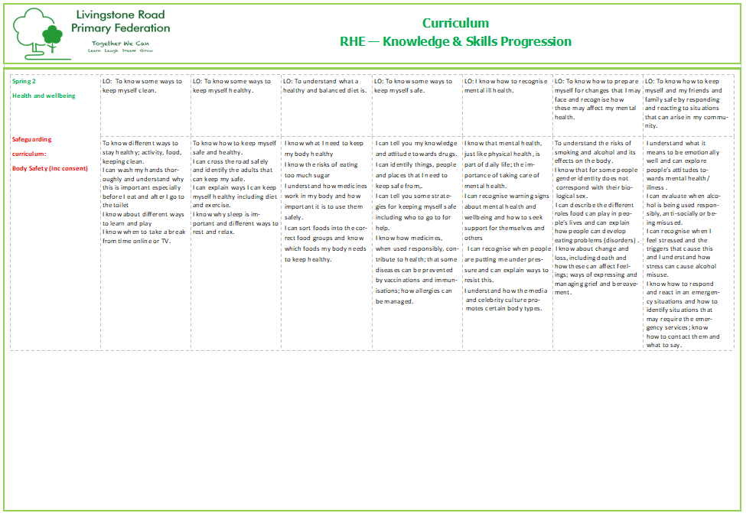

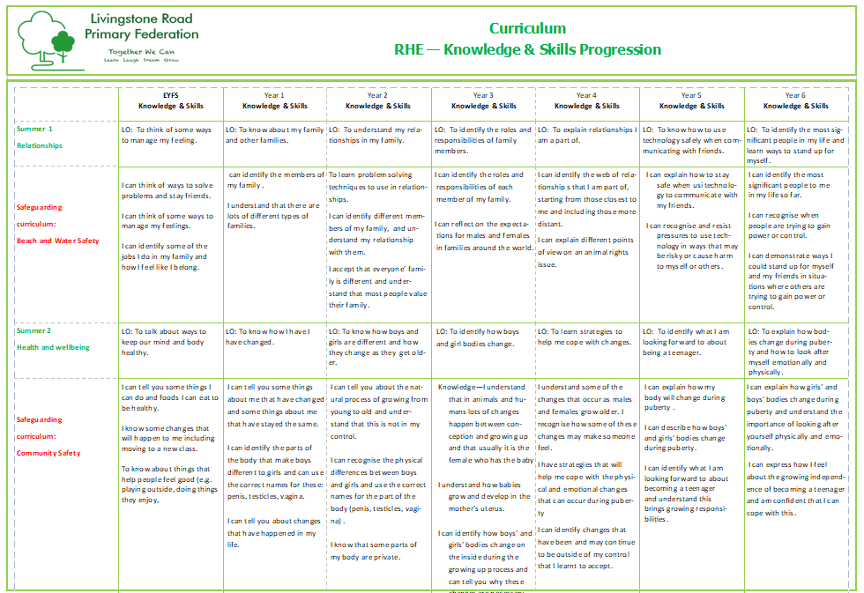

Review

This policy will be reviewed annually by the Policy Owner.

