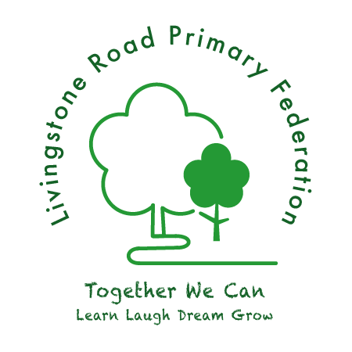
Little Livingstone’s Preschool Admissions Policy

Our Little Livingstone’s Preschool booklet and Admission forms contain all the details about our session times, costings etc. This information is also available in the Little Livingstone’s section of the Infant School website.
The Preschool is open to every family in the community, regardless of gender, sexuality, class, family status, means, colour, disability, ethnic group, religion, belief or the length of time living in the community. We will endeavour to be flexible when trying to accommodate the needs of individual children and their families.
The Nursery offers care for children from the age of 2 years up to school age.
Admissions will be based on a first come, first served basis according to the waiting list. Applications for siblings within the school may take precedence; the final decision is with the Preschool leader and Executive Headteacher.
Children can join the Preschool at any time during the year, as long as there are spaces available. Prior to a child attending Little Livingstone’s Preschool, parents must complete Admissions forms and return a copy of the signed terms and conditions, this must include the BCP funding form.
We encourage parents to come to the preschool with their child before they start in order that they can meet the staff and other children and have the opportunity to gain familiarity with the surroundings.
In the event that a start date is delayed, unless otherwise agreed, fees are due as from the originally agreed start date
Attending the Preschool does not automatically guarantee a space in the main school and applications for a school place should be completed through BCP Council school admissions at the relevant time.

