PE Funding

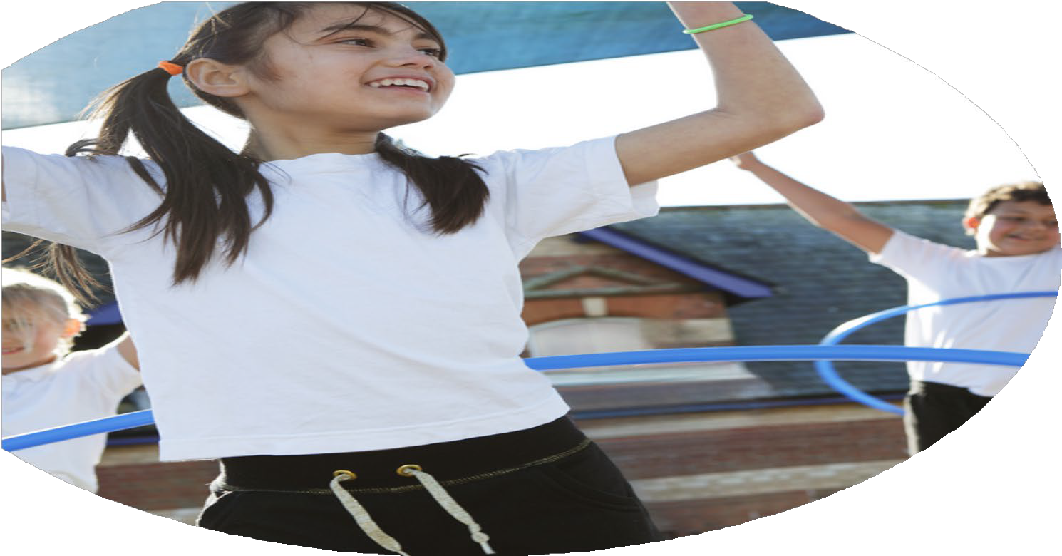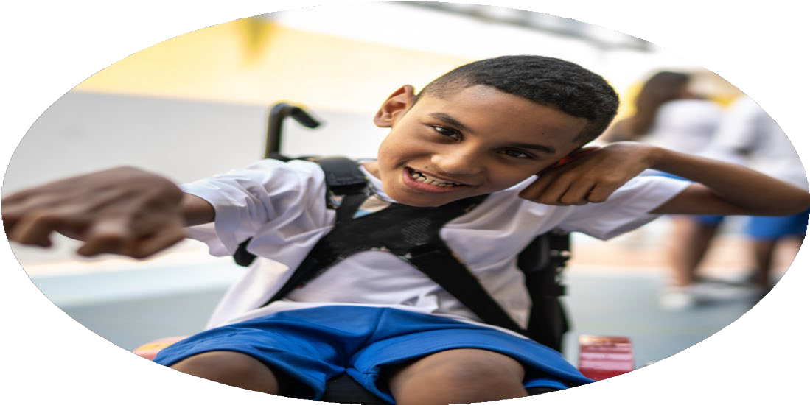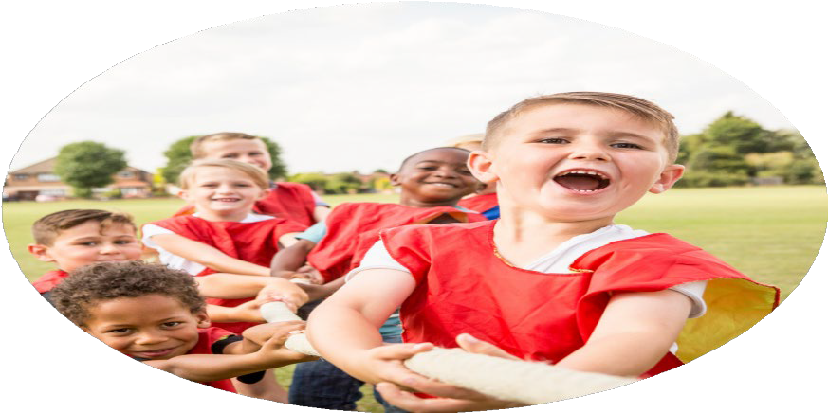

Evaluation Form

**Commissioned by**

**Created by**

Images courtesy of Youth Sport Trust

**PE Funding Evaluation Form**

 It is intended that this template should be used as preparation for the completion of the statutory digital reporting tool being introduced this academic year. You can upload data (including swimming) from this template onto this platform once it becomes accessible.

 Before you decide how you are going to use the funding for this academic year you should reflect and evaluate the impact of your use of the funding in 2023/24.

 All spending of the funding must conform with the terms outlined in the Conditions of Grant document.  The template is a working document that you can amend/update during the year.

 Based on your evaluation of last year’s funding you should decide what you intend to do this academic year, how you will do it, and what impact you expect it to have.

It is important that the funding is used effectively and based on your school’s needs.

 You must use the funding to make additional and sustainable improvements to the PE and sport in your school.  You must develop and add to the PESSPA activities that your school already offers.

*Summative digital reporting from June 2025 will continue to include swimming and water safety information therefore funding can be used to provide top-up lessons where necessary to ensure pupils meet national curriculum swimming requirements.*

**We recommend that you start by reflecting on the impact of current provision and reviewing your previous spend**

|  |  |  |  |
| --- | --- | --- | --- |
| What went well? | How do you know? | What didn’t go well? | How do you know? |
| Successful Sports Day  Implemented new PE scheme of work. | Feedback from staff, students and parents  Feedback from staff. | Engagement in after school clubs and the provision provided | Feedback from students and own observations. |

|  |  |
| --- | --- |
| What are your plans for 2024/25? | How are you going to action and achieve these plans? |
| Intent | Implementation |
| To improve afterschool club provision.  To improve opportunities for all children to take part in competitive sports.  Allow children to take part in a wider range of activities, including OAA. | Gather ideas from our pupils using House captains and then communicate with providers to change and adapt clubs to suit those results.  To provide interhouse competition half termly within each year group.  To seek to provide opportunities via School Games Organisers to represent the school.  Provide Forest School sessions for every child for a half term and engage children in OAA activities including rock climbing and caving. |

|  |  |
| --- | --- |
| What impact/intended impact/sustainability are you  expecting? | How will you know? What **evidence** do you have or  expect to have? |
| We aim to promote more opportunities for regular physical activity among our pupils whilst creating closer links with our community. These clubs will also provide positive role models for our pupils and allow all children regardless of vulnerability the same opportunities.  Improved levels of competitive sports will increase children’s self-worth and self-confidence whilst offering opportunities to improve their communication skills.  We want to broaden the opportunities that our pupils experience as we have a fairly disadvantaged community. | Feedback from staff, pupils and parents will be gathered. |

|  |  |
| --- | --- |
| What **impact/sustainability** have you seen? | What **evidence** do you have? |
| Afterschool club provision.   * Increased range of clubs with a greater range of sports * Increased number of children attending clubs * Improved confidence of pupils taking part in different sports * Engagement from target groups of children e.g. girls and pupil premium * Increased activity in the school day as a result of more opportunities   Competitive sport   * Children have been able to compete in a low-stakes environment * More children have represented the school   Broader range of activity   * Engagement from all pupils regardless of background * Children have built and improved their self-worth and self-confidence * Discovered new skills | Club attendance registers  Pupil voice surveys  Active Lives Survey |